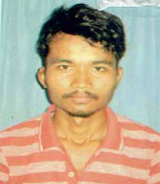**CURRICULUM VITAE**

**DEVIT DEORI**

Mobile : 91–9854717046

Email Id :devitdeori2@gmail.com

Address: C/O. – Magh Mohan Deori

Vill. – 2 No Dolabari

P. O. –Kaliabhomora, P. S. - Tezpur

Pin – 784001,Dist. – Sonitpur (Assam)

**CARRIER OBJECTIVES**

To obtain a position is an organization, where I can constantly contribute my knowledge, skills and intelligence to its growth and simultaneously keep adding values to myself.

**EDUCATIONAL QUALIFICATION**

* 3 Years Diploma Course in Agricultural Engineering from HRH The Prince of Wales Institute of Engineering & Technology
* H.S passed under AHSEC
* HSLC pased under SEBA

**OTHER QUALIFICATION& TRAINING**

* PGDCA& DCA
* B.MUSIC ( Violin)
* Auto CAD
* North Eastern Region Fram Machinery Training & testing Institute

**WORK EXPERIENCE**

* 2 Year 7 Months Experience Sonalika Tractors( Service Advisor )

**PERSONAL SKILLS**

Comprehensive problem solving abilities, excellent verbal and written communication skills, ability to deal with people diplomatically, willingness to learn, team facilitator.

**PERSONAL PROFILE**

Name : Devit Deori

Father’s Name : Megh Mohan Deori

Gender : Male

Cast : ST

Marital Status : Married

Nationality : Indian

Date of Birth : 20-03-1996

Languages known : English, Hindi & Assamese

Permanent Address : C/O.–Magh Mohan Deori

Vill. –2 No Dolabari

P. O. –Kaliabhomora, P. S. - Tezpur

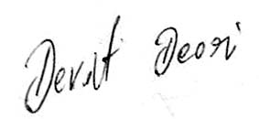Pin – 784001, Dist. – Sonitpur (Assam)

**Date : 17-03-2021**

**Place :Tezpur**  **Signature**